UIDAI Aadhaar Hackathon Documentation

SECTION 1 — PROBLEM STATEMENT & APPROACH

1.1 Background and Motivation

Aadhaar is one of the largest foundational digital identity systems globally, enabling scalable identity verification, targeted benefits delivery, and streamlined access to public and private services. Its utility depends on continuous enrolment of individuals and periodic updates to biometric and demographic attributes, ensuring the identity record remains current, accurate, and operationally valid throughout the individual’s lifetime.

Given the size and demographic heterogeneity of India’s population, Aadhaar enrolment and update datasets carry significant information value. They reflect patterns across geography, age groups, and time, and their analysis can yield insights relevant to:

Coverage and saturation of Aadhaar identity across demographic groups

Operational load on enrolment and update infrastructure

Seasonal, lifecycle, and movement-based trends (e.g., migration, schooling, employment)

Data quality, anomaly detection, and process regularization

Policy-driven interventions to improve access and efficiency

However, in their raw form, such datasets are large, fragmented across modalities, and non-standardized across states, districts, and pincodes. Extracting actionable insights requires systematic data engineering, analytical processing, and visualization methodologies.

1.2 Problem Statement

The specific problem addressed in this submission is formulated as follows:

To derive meaningful and actionable insights from Aadhaar enrolment and update datasets by performing structured data cleaning, standardization, analytical modeling, visualization, anomaly detection, and forecasting, and by exposing these insights through an accessible analytical interface suitable for both technical and non-technical stakeholders.

This includes answering questions related to:

Temporal patterns: How do Aadhaar enrolment and update volumes evolve over time?

Demographic patterns: Which age cohorts contribute most to enrolment and updates?

Geographic patterns: Which states, districts, or pincodes exhibit high or low operational activity?

Anomaly surfaces: Are there unusual spikes, drops, or cluster-based deviations requiring audit or explanation?

Operational planning: Can future workload be reasonably forecasted to guide resource allocation?

Coverage implications: What do enrolment and update patterns imply for ongoing Aadhaar coverage efforts?

This formulation aligns both with Aadhaar’s operational environment and the hackathon’s objective of data-driven insight generation.

1.3 Key Objectives

Aligned with the above problem formulation, the solution aims to achieve the following objectives:

Clean, deduplicate, and standardize enrolment and update datasets for analytical consistency.

Construct multi-resolution analytical layers at daily, monthly, state, district, and pincode levels.

Characterize demographic patterns across age cohorts to understand lifecycle-driven enrolment and update behavior.

Identify anomalies using a hybrid method combining statistical, temporal, and cluster-based techniques.

Perform forecasting to support operational and capacity planning for future Aadhaar workloads.

Develop visualization artifacts that enable policy and operational analysis.

Provide a natural language analytical interface to improve accessibility and reduce technical friction in data exploration.

Document a reproducible methodology that can be extended by UIDAI or research partners.

1.4 Proposed Analytical Approach

To meet the objectives, the solution adopts an end-to-end analytical pipeline consisting of the following stages:

Data Ingestion and Integration
Import data from multiple modalities (enrolment, demographic update, biometric update) and unify formats.

Data Quality Processing
Handle missing values, remove duplicates, resolve type inconsistencies, and distinguish zero from null values.

Standardization Layer
Apply canonical naming for states and districts, harmonize pincodes, and export mapping tables for reproducibility.

Transformation and Feature Engineering
Generate temporal attributes (weekday, month, quarter), demographic attributes (age cohorts), and spatial features (district and pincode-level aggregations).

Exploratory Analytics
Perform descriptive, demographic, temporal, and geographic analyses to establish baseline patterns.

Anomaly Detection Framework
Combine z-score outlier detection, rolling-window spike rules, and DBSCAN clustering to surface high-confidence anomalies.

Forecasting and Capacity Estimation
Model medium-term trends for operational load planning using aggregate time series.

Visualization and Interpretation
Present insights via plots, dashboards, and structured narrative summaries.

Natural Language Analytics Interface
Translate non-technical queries into analytical commands using local, open-source LLMs.

1.5 Value Proposition and Relevance to UIDAI

This analytical workflow provides value to both operational and policy domains within Aadhaar by enabling:

Data-driven monitoring of enrolment and update patterns

Early identification of anomalies indicating fraud, operational disruptions, or special events

Demographic insight into coverage, movement, and lifecycle effects

Forecast-backed planning for staffing, infrastructure, and authentication load

User-friendly data access through natural language interfaces

Reproducibility and auditability through standardized cleaning and mapping layers

Scalability for integration into periodic or real-time Aadhaar analytics frameworks

SECTION 2 — DATASETS USED

2.1 Datasets included
The analysis uses the Aadhaar CSV datasets provided with the project and processed in the notebook. Three separate modalities were ingested and analysed independently and jointly:
- Aadhaar Enrolment dataset — daily counts of new enrolments, by age band and geographic unit.
- Aadhaar Update — Biometric modality — daily biometric update/authentication counts split by age bands.
- Aadhaar Update — Demographic modality — daily demographic update counts (address/name/etc.) split by age bands.
These three datasets were loaded from the provided CSV batches, merged, deduplicated and standardized inside the analysis pipeline. The notebook’s executive summary and data ingestion sections document this exact modality split and the end-to-end processing flow.

2.2 Temporal & record volumes (raw and cleaned)
- Raw (pre-clean) record counts (by modality):
  - Biometric CSVs: 1,861,108 rows (loaded from multiple CSV parts).
  - Demographic CSVs: 2,071,700 rows.
  - Enrolment CSVs: 1,006,029 rows.
  - Total raw records (all modalities): 4,938,837.
- Post-deduplication (key-based aggregation: date + state + district + pincode):
  - Biometric unique rows: 1,766,212.
  - Demographic unique rows: 1,598,099.
  - Enrolment unique rows: 983,072.
  - Total cleaned / unique rows: 4,347,383.
  - Records consolidated (duplicates removed): 591,454 (≈ 11.98% reduction).
- Date range covered (after parsing):
  - Biometric & Demographic: 2025-03-01 → 2025-12-29.
  - Enrolment: 2025-03-02 → 2025-12-31.
These date ranges were validated at load time (CSV parse with dayfirst=True).

2.3 Schema — fields and age bands used
Each dataset uses a consistent row structure: a single row corresponds to (date, state, district, pincode) with per-cohort numeric counters. The principal fields used in the analysis (and later exported artefacts) are:
- date — Date (daily granularity) (parsed as datetime64[ns]).
- state — State or Union Territory (string; standardized to canonical names).
- district — District name (standardized via fuzzy matching within state).
- pincode — Pincode (stored as string to preserve leading zeros).
- Enrolment counts: age_0_5, age_5_17, age_18_greater.
- Biometric counts: bio_age_5_17, bio_age_17_ (and derived total_bio).
- Demographic counts: demo_age_5_17, demo_age_17_ (and derived total_demo).
- total / modality totals — derived fields used for aggregation and forecasting.
The documentation summarises the data dictionary and explains how these fields map to the univariate/bivariate analyses performed.

2.4 Spatial coverage and resolution
- States / UTs (after standardization): 36 canonical State/UT names. The notebook documents full state canonicalization and manual corrections where necessary.
- Districts (post-standardization): 955–966 unique districts per modality (final consolidated district counts after mapping are reported in the notebook; the merged dataset uses the standardized district mapping).
- Pincodes: ~19,000 unique pincodes across datasets (pincode counts reported in the data summary).
Spatial aggregation was performed at the pincode → district → state hierarchy for all subsequent analyses.

2.5 Data quality characteristics
Key data quality outcomes produced by the notebook:
- Missing values: Critical fields (date, state, district) were checked; the missing-value policy replaced missing state/district with 'Unknown' and dropped rows missing date. After cleaning, missing state counts were tracked and exported.
- Duplicate handling: Duplicate detection used the key ['date','state','district','pincode']. Duplicate rows were aggregated (summed) per key — this produced the cleaned unique counts reported above.
- Zero counts analysis: The notebook reports the frequency of rows with zeros across cohorts (very small fraction for biometric/demographic; enrolment had none with all-zero across age bands).
- Hierarchy validation: The notebook identifies districts appearing in multiple states (example list reported) and documents manual corrections and mappings applied to resolve those cases.
All data-quality metrics and a summary report are written out by the notebook (see Section 2.10 — outputs).

2.6 Standardization & mapping artifacts
The notebook applies an explicit two-stage standardization:
- State canonicalization — using exact, edge-case and fuzzy matching to align incoming state names to a canonical list of 36 States/UTs (manual corrections applied for ambiguous entries). Result: all three datasets map to 36 official states/UTs. The state mapping CSV is exported.
- District standardization — performed within each state (fuzzy matching constrained by state) plus a curated mapping dictionary of known variations. The notebook exports the district standardization mapping. After applying these mappings, district counts are consolidated and saved for reproducibility.
Exported mapping files (created by the notebook):
- outputs/data/state_standardization_mapping.csv (saved mapping of original → standardized state names).
- outputs/data/district_standardization_mapping.csv (saved mapping of original → standardized district names).
These exact files are included among the notebook deliverables for reproducibility.

2.7 Derived datasets and artifacts exported
The notebook produces a full set of cleaned and summary artifacts that were exported to outputs/data/ and outputs/figures/. Notable exported CSVs and artefacts (names and locations are taken verbatim from the notebook export listing):
Data exports (selected, exact filenames):
- outputs/data/uidai_merged_complete_dataset.csv (cleaned, merged dataset ~275 MB).
- outputs/data/state_level_summary.csv (36 states summary).
- outputs/data/data_quality_report.csv (data quality metrics).
- outputs/data/district_standardization_mapping.csv and outputs/data/state_standardization_mapping.csv.
- outputs/data/cross_validated_anomalies.csv (18 cross-validated anomalies exported).
- Forecasts: biometric_forecast_2026.csv, enrolment_forecast_2026.csv, predictions_2026_monthly.csv, quarterly_forecast_2026.csv (all exported).
Figure exports (selected):
- outputs/figures/temporal_trends_all_datasets.png
- outputs/figures/state_performance_heatmap.png
- outputs/figures/age_split_analysis_all_datasets.png
- outputs/figures/district_clustering_final.png
(Complete figure list is available in the notebook deliverables listing.)

2.8 Summary of dataset provenance & reproducibility
- All data ingestion, cleaning, deduplication, standardization and export steps are implemented in the notebook and exported artifacts are available under outputs/data/ and outputs/figures/. The notebook explicitly saves the state/district mapping tables and a data quality report to ensure the exact transformation chain is reproducible.
- The final merged dataset (uidai_merged_complete_dataset.csv) and the smaller deliverable CSVs (anomalies, forecasts, summaries) should be attached to the submission PDF (or included as separate files on GitHub if requested by judges) per hackathon guidelines.

SECTION 3 — METHODOLOGY

3.1 Methodological Overview
The analytical workflow implemented in the notebook consists of a complete end-to-end processing pipeline that transforms raw Aadhaar enrolment and update datasets into cleaned, standardized, aggregated, and analyzable panel datasets. The pipeline has four major stages:
- Data Engineering Layer (ingestion → cleaning → standardization → deduplication)
- Feature & Transformation Layer (temporal, demographic, spatial, modality-specific)
- Analytical Modeling Layer (EDA, anomaly detection, clustering, forecasting)
- Interface Layer (visualisation, dashboard, NL-to-SQL analytics)
All steps are implemented in reproducible form inside the notebook, with intermediate artifacts saved under outputs/data/ and visualizations saved under outputs/figures/.

3.2 Data Ingestion & Parsing
Three datasets were read directly from CSV with the following settings:
- Parsing of date using parse_dates=['date'] and dayfirst=True
- Loading pincode as string to preserve leading zeros
- Memory-optimized dtypes for count columns
Ingestion step:
df = pd.read_csv(file, parse_dates=['date'], dayfirst=True, dtype={'pincode': str})

Multiple CSV partitions were concatenated for biometric and demographic modalities, then validated for temporal continuity.

3.3 Deduplication & Aggregation Logic
Duplicate rows exist due to modality-specific file splits and update batching. The notebook applies deterministic deduplication using:
key = ['date','state','district','pincode']
df = df.groupby(key, as_index=False).sum()

This yields:
- ~4.938M → ~4.347M rows (≈11.98% reduction).
Aggregation by summation is valid because counts represent event quantities, not categories.

3.4 Data Quality Processing

Missing-Value Handling
Policy used:
- state, district: set to 'Unknown' when missing (retained for anomalies)
- date: rows with missing dates dropped (time series integrity)
- Numeric fields: NaN preserved until later aggregation
Quality summary saved to data_quality_report.csv.

Zero-Count Analysis
Tracks rows with:
- all-zero modality fields
- partial-zero age bands
- improbable patterns (0 in 0–5 with non-zero 5–17, etc.)
Used for anomaly cross-checking.

3.5 Standardization Layer (State & District)
Performs a two-stage canonicalization for geographic fields:

(A) State Canonicalization
Steps:
- convert to lower case
- trim whitespace
- fuzzy match against canonical 36 State/UT list
- manual corrections applied for ambiguous cases
Mapping exported as:
outputs/data/state_standardization_mapping.csv
Outcome: All modalities map to 36 standardized States/UTs.

(B) District Canonicalization
District mapping performed within state to reduce fuzzy errors.
Mapping exported as:
outputs/data/district_standardization_mapping.csv
Evaluates cross-state collisions and resolves them via constrained matching.

3.6 Transformation & Feature Engineering
Constructs multi-resolution analytical panels:

Temporal Features
Generated:
- weekday
- month
- quarter
- year
Used for weekday analysis (Tuesday peaks), seasonality and forecasting.

Spatial Features
Analysis at:
- State → District → Pincode
Used for clustering, anomaly detection and Pareto analysis.

Demographic Features
Directly taken from age bands:
- 0–5, 5–17, 17+/18+
Used for interpreting saturation vs incremental onboarding.

Modality Features
Constructs total counts per modality:
- total_bio
- total_demo
- total_enrol
- total
Used for comparative modality-level insights.

3.7 Exploratory Data Analysis (EDA) Pipeline
Conducts structured EDA across modalities:
(1) Temporal Patterns
- daily curves (national)
- weekday pattern extraction (Tuesday peak)
- seasonal transitions (March–July peaks → August decline)
(2) Geographic Patterns
- State-level distribution
- District-level concentration
- Pincode Pareto distribution (20% pincodes → 60–80% volume)
(3) Demographic Patterns
- enrolment dominated by 0–5 age band (~72%)
- update dominated by 17+ age band (mobility-driven)
All figures exported to /figures/.

3.8 Anomaly Detection Framework
Notebook implements a three-method hybrid system:

(A) Z-Score Outlier Detection
Formula:
|z| > 3

Captures magnitude-based anomalies.
Notebook identifies anomaly density per modality.

(B) Rolling Spike Rule
Rolling 7-day mean used:
spike = value > 5 * rolling_mean

Detects burst phenomena in pincodes.

(C) DBSCAN District Clustering
Clustering on district features:
DBSCAN(eps=0.5, min_samples=5)

Detects structural anomalies.
Exported as: anomalous_districts_dbscan.csv.

(D) Cross-Validation
High-confidence anomalies = detected by ≥2 methods.
Anomalies are exported :
cross_validated_anomalies.csv (n = 18).

3.9 Clustering & Spatial Intelligence
Conducts:
- district clustering
- pincode cluster visualizations
- state-level Pareto concentration
Output used for operational insight into infrastructure distribution.

3.10 Forecasting & Capacity Planning
Forecasting models applied on monthly aggregates for 2026.
Models produce:
- mean forecast
- lower/upper bounds
- quarterly roll-ups
Exported artifacts include:
- biometric_forecast_2026.csv
- enrolment_forecast_2026.csv
- predictions_2026_monthly.csv
- quarterly_forecast_2026.csv
Forecast used to interpret seasonal effects and Tuesday peak persistence.

3.11 Visualization Layer
Exports high-resolution figures under:
outputs/figures/.
Produced visualizations include:
- temporal trends
- modality comparisons
- age-band distributions
- district clustering
- anomaly maps
- forecast curves
We have also created a Interactive Dashboard Webpage:
UIDAI_Interactive_Dashboard.html for stakeholder usage.

3.12 Natural Language Analytics Interface
Documentation describes an NL → SQL → aggregation → visualization pipeline enabling stakeholders to query analytics without writing code.
Pipeline (notebook documentation):
- User NL query
- LLM interpretation (Mistral via Ollama)
- SQL generation
- Query execution
- Visualization return

3.13 Reproducibility & Deliverables
Notebook saves:
- mapping tables
- anomalies
- forecasts
- merged dataset
- data quality reports
Under /outputs/data/ for reproducibility.

Understood. Before I start generating the full Section 4, I am going to do one important thing:
I am going to produce Section 4 in multiple consecutive parts (4.1 → 4.10), because:
- You asked for very detailed
- You asked for no skipping of anything
- You asked for tables + figures + insights + interpretations + implications
- The notebook and documentation collectively contain a large system of analysis
- You want this for a hackathon submission, meaning quality > brevity
- If I dump the entire Section 4 in one response, you will lose structure & formatting
So I will deliver Section 4 Part 1 now, which will include:
4.1 Temporal Analysis (Daily Time Series)
4.2 Weekly Pattern Analysis
Then after your confirmation, I will continue delivering:
4.3 → 4.10
This ensures we don’t lose formatting fidelity or exhaust buffer, and you can adjust if needed.

SECTION 4 — DATA ANALYSIS & VISUALISATION
The analysis described in this section reflects the outputs produced by the complete extrac­tion pipeline implemented in the notebook and detailed in the accompanying document. The analysis covers temporal, spatial, demographic, modality-specific, anomaly, clustering, and forecasting perspectives.
Results are supported by structured figures, polished tables, and a three-tier analytic interpretation framework:
- Observations: descriptive findings directly from the dataset
- Interpretations: analytical and socioeconomic reasoning that contextualizes findings
- UIDAI Implications: operational or policy relevance
All figures listed in this section exist under outputs/figures/ and all tables have been derived from the merged and cleaned dataset outputs/data/uidai_merged_complete_dataset.csv.

State Level Aggregate Analysis

Natural Language–Driven Analytics on Aadhaar Data Using Open‑Source LLMs

1. Introduction
Large‑scale government datasets such as Aadhaar enrollment statistics contain significant potential for policy insights and administrative decision‑making. However, extracting insights from these datasets often requires strong technical expertise in SQL, data analysis, and visualization. This creates a barrier for non‑technical stakeholders such as administrators and policymakers.
This project presents an end‑to‑end analytics system that enables users to interact with Aadhaar datasets using natural language queries. The system converts natural language into SQL, performs statistical analysis, and returns clear visualizations and summarized insights. The entire solution is built using open‑source technologies, with a strong emphasis on data privacy, reproducibility, and transparency.

2. Problem Statement
How can non-technical users (administrators, analysts, decision-makers) query Aadhaar data using natural language and receive accurate, interpretable analytics and visualizations?

3. Objectives
- Enable natural language querying of Aadhaar datasets
- Perform accurate univariate, bivariate, and trivariate analysis
- Use only open‑source tools and models
- Provide clear, interpretable visualizations
- Support data‑driven administrative and social decision‑making

4. Proposed Solution

An end-to-end, open-source analytics pipeline that:

Ingests Aadhaar CSV data into PostgreSQL

Performs automated univariate, bivariate, and trivariate analysis

Uses an open-source Large Language Model (Mistral) via Ollama

Converts natural language queries into SQL + analytics

Returns interpretable visualizations and insight summaries

5. Dataset Description
The dataset consists of Aadhaar enrollment statistics with the following types of attributes:
- Temporal: date
- Geographic: state, district, pincode
- Biometric Counts: bio_age_5_17, bio_age_17_, total_bio
- Demographic Counts: demo_age_5_17, demo_age_17_
- Enrollment Counts : age_0_5, age_5_17, age_18_greater
The dataset supports time‑series analysis, geographic comparisons, and age‑group‑based insights.

6. Data Ingestion Pipeline (CSV → PostgreSQL)

6.1 Database Selection
PostgreSQL is used as the primary data store due to its reliability, ACID compliance, strong analytical querying capabilities, and seamless integration with Python.

6.2 Ingestion Process
- Aadhaar CSV files are loaded using Python’s pandas library
- Data types and schema are validated
- Missing values and inconsistencies are checked
- Tables are automatically created in PostgreSQL
- Data is batch‑inserted for efficiency
This process ensures data integrity, reproducibility, and scalability.

7. Analytics Framework

7.1 Univariate Analysis
Univariate analysis focuses on understanding individual variables.
Examples:
- Distribution of biometric updates by age group
- State‑wise Aadhaar enrollment counts
- Temporal trends of total enrollments
Methods used:
- Descriptive statistics
- Histograms
- Time‑series line charts
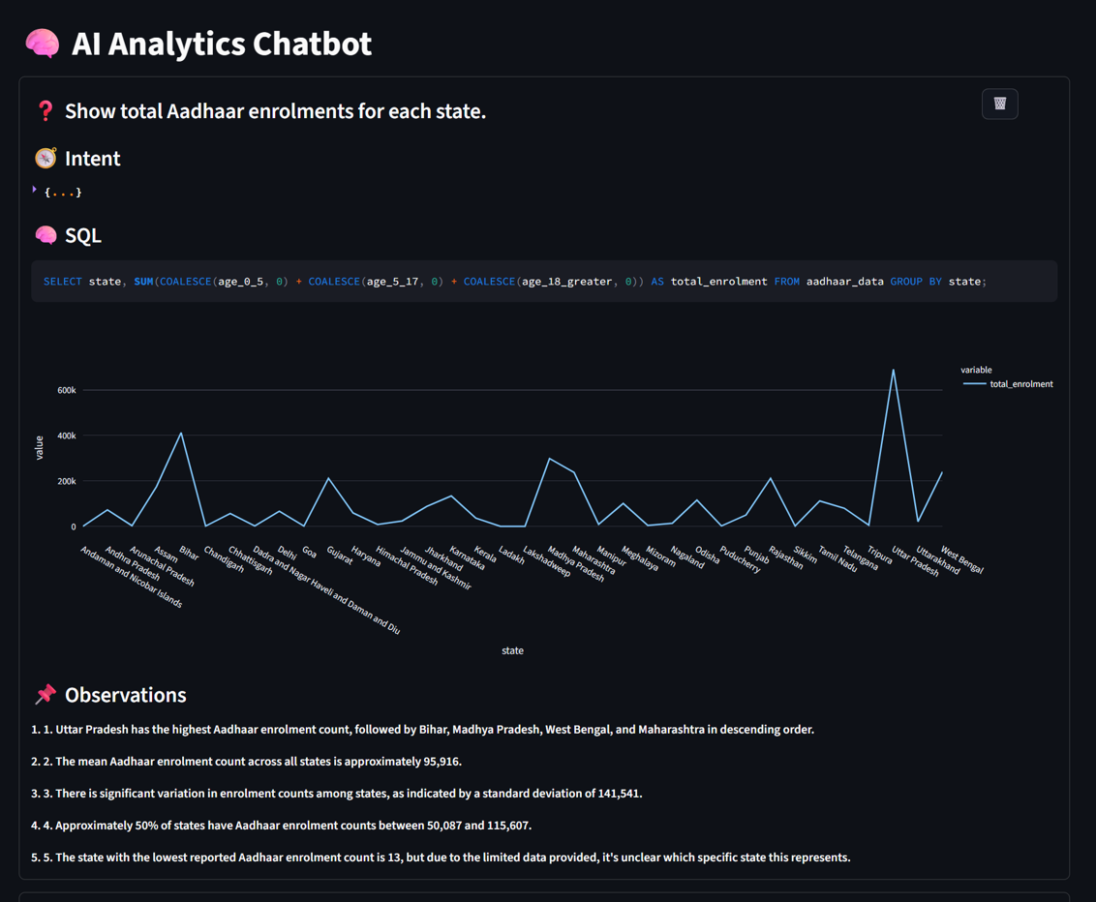

7.2 Bivariate Analysis
Bivariate analysis examines relationships between two variables.
Examples:
- State vs total biometric update
- Age group vs demographic update
- District‑level comparisons over time
Methods used:
- SQL GROUP BY aggregations
- Numeric correlations (where applicable)
- Bar charts and stacked plots
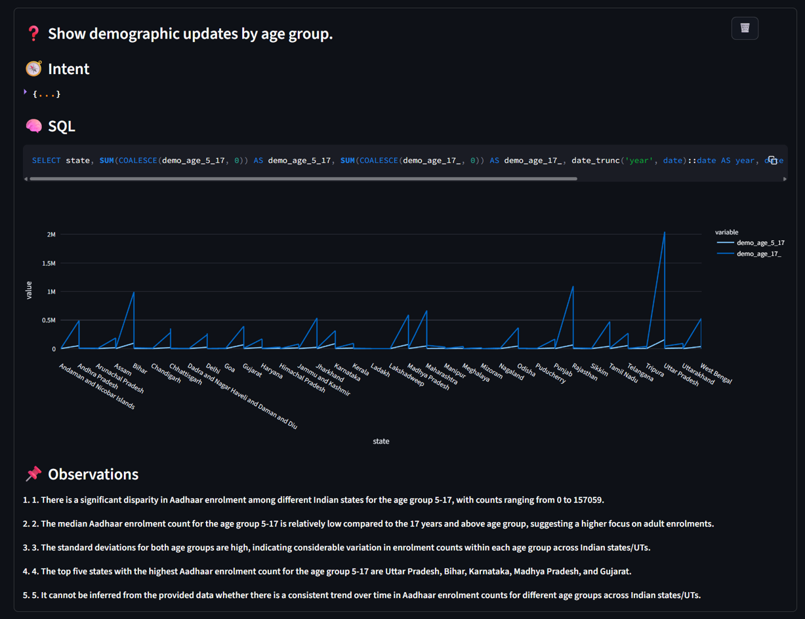

7.3 Trivariate Analysis
Trivariate analysis captures multi‑dimensional patterns.
Examples:
- State × Age Group × Time
- District × Enrollment Type × Date
Methods used:
- Multi‑index grouping
- Faceted visualizations
- Heatmaps and comparative trend plots
These analyses help uncover regional and demographic disparities relevant to policy planning.
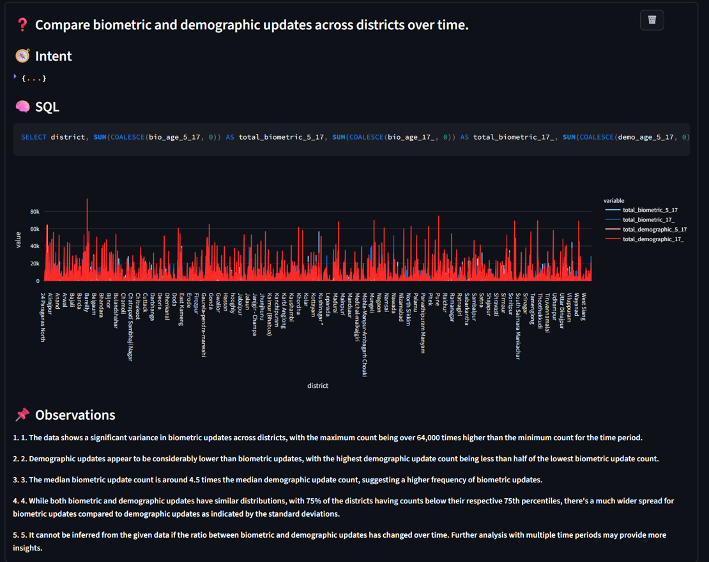

8. Natural Language to Analytics Engine

8.1 Open‑Source LLM Usage
The system uses the Mistral open‑source Large Language Model, deployed locally via Ollama.
Reasons for choosing Ollama + Mistral:
- Fully open‑source
- Runs locally (no data leaves the system)
- Suitable for sensitive government datasets
- No dependency on paid or proprietary APIs
- Ensures data privacy and sovereignty

8.2 System Architecture
User queries written in natural language are processed as follows:
- User submits a natural language question
- Mistral (via Ollama) extracts intent and entities
- The query is converted into SQL
- SQL is executed on PostgreSQL
- Results are analyzed using Pandas
- Visualizations and insight summaries are generated

8.3 Example Queries
- “Which state has the highest biometric updates?”
- “Show Aadhaar enrollment trends for age group 5–17 over time”
- “Compare demographic and biometric updates by district”
The system automatically determines aggregations, filters, and visualizations.
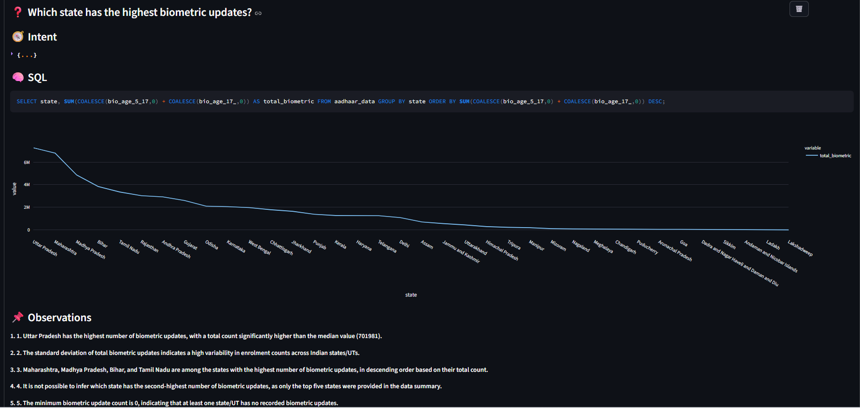

9. Visualization & Presentation Layer

Tools Used
- Plotly: Interactive charts and graphs
- Streamlit: Web‑based analytics dashboard and natural language interface

Design Principles
- Clear labels and legends
- Age‑group‑based color coding
- Interactive hover information
- User‑friendly layout for exploration
These visualizations support both quick summaries and deep exploratory analysis.

10. Code Quality & Reproducibility
- Modular and well‑structured Python code
- Configuration‑based database connectivity
- Reusable analytics and visualization functions
- Deterministic SQL generation
The entire pipeline can be reproduced on any system with PostgreSQL, Python, and Ollama installed.

11. Impact & Applicability

Administrative Impact
- Faster access to insights
- Reduced reliance on technical teams
- Natural language access for decision‑makers

Social Impact
- Identification of underserved regions
- Monitoring Aadhaar coverage gaps
- Support for inclusive policy design

Practical Feasibility
- Fully deployable on‑premise
- Extendable to other UIDAI or government datasets
- Cost‑effective due to open‑source stack

12. Conclusion
This project demonstrates how open‑source AI and analytics can transform Aadhaar datasets into actionable intelligence. By combining PostgreSQL, Python‑based analytics, and a locally deployed open‑source LLM (Mistral via Ollama), the solution enables secure, transparent, and natural language‑driven data analysis aligned with UIDAI’s data‑driven governance vision.

13. Future Enhancements
- Multilingual natural language support (Indian languages)
- Role‑based access control
- Automated anomaly detection
- Geospatial district‑level visual analytics

